FIELD REPORT
Introduction
- Abwoch HC III
- Location: Omoro district, Apuga, Abwoch
- Date of visit: 1ST September 2026
- General observation
The health facility was visited to physically verify the assets reportedly provided under the UGIFT project. The verification was conducted in consultation with the facility in charge, and the assets were assessed based on their physical presence, condition, location, and available supporting documentation/knowledge.
- At the time of the visit, the maternity block was not fully operational due to ongoing construction and repair works. The facility in charge explained that the block had initially been in use but was subsequently rendered non-functional as construction and corrective works continued. This resulted in the removal and relocation of assets from the block.
- At the time of verification, a number of the assets were found stored within an accessible section of the maternity block, where they had been consolidated and piled together. The arrangement of the assets made it difficult to clearly distinguish individual items and establish which assets were specifically supplied under the UGIFT project. Where possible, the assets were physically assessed against the information provided in the verification checklist and the documentation available at the facility.
- The facility had engraved its assets following the order “ABWOCH H/C III/00”; however, the engraving was applied across assets at the facility and was not specific to UGIFT-supported assets. Consequently, the engraving could not be used as a unique identifier for distinguishing UGIFT assets from assets acquired through other sources.
2. Asset verification observations
During the physical verification exercise, verification was limited to the assets that the facility in-charge indicated with reasonable certainty had been supplied under the UGIFT project. Due to the absence of project-specific identification on the assets and the incomplete asset register, it was not possible to independently establish the PIP origin of all items observed at the facility.
The facility in-charge further reported that some of the assets that could not be verified were stored in a separate store that also serves as staff quarters. The staff member occupying the quarters was not present at the time of the visit, and access to the room was therefore not possible. Consequently, the team was unable to physically inspect or verify the items reportedly kept in that location. These items have therefore been treated as unverified based on the information available at the time of the visit.
3. Key issues/challenges
- The absence of project-specific asset identification presented a significant challenge during verification. Although assets had been engraved, the same engraving approach had been applied to assets across the facility. There was therefore no clear physical identifier to distinguish UGIFT-supported assets from other facility assets.
- The asset register presented by the facility in charge was reported to be incomplete. He indicated that the staff member assigned to update and maintain the register had not completed the exercise. In addition, the available register provided a general listing of facility assets but did not indicate which assets had been supplied under the UGIFT project. This limited the ability to use the register as a basis for independently identifying UGIFT-supported assets.
- The ongoing construction and repair work at the maternity block significantly affected the accessibility, storage, and organization of the assets. According to the facility, the block had initially been in use but became non-functional as construction and repair works continued without full completion. As a result, the assets had to be removed from the block and were temporarily stored outside, including under a tree, before the facility was later granted access to part of the block. The prolonged movement and temporary storage of the assets may also have contributed to changes in their condition.
- At the time of the visit, the assets were largely piled together in the accessible section of the maternity block. The limited space and manner in which the items were stored made it difficult to individually identify, access, and verify assets against the UGIFT project records. This particularly affected the ability to establish a clear link between the physically observed assets and the assets reported as having been supplied under the project.
Special note:
Asset register and verification records
The District Headquarters did not have records indicating the assets that had been supplied to Abwoch Health Center III under the UGIFT project. This limited the ability to cross-reference the assets observed at the facility against district-level records. Following consultations with relevant stakeholders, the team contacted the suppliers using the contact information provided at the district. The supplier was subsequently reached, and additional information was shared; however, this information was received after the verification exercise had already been completed and the team had departed from the health facility. It therefore could not be used to inform or independently validate the physical verification conducted during the visit.

The table below illustrates some physical status of the verified assets with photographic evidence.
Table XXX: Physical verification photos
ABWOCH HC III SIGN POST | 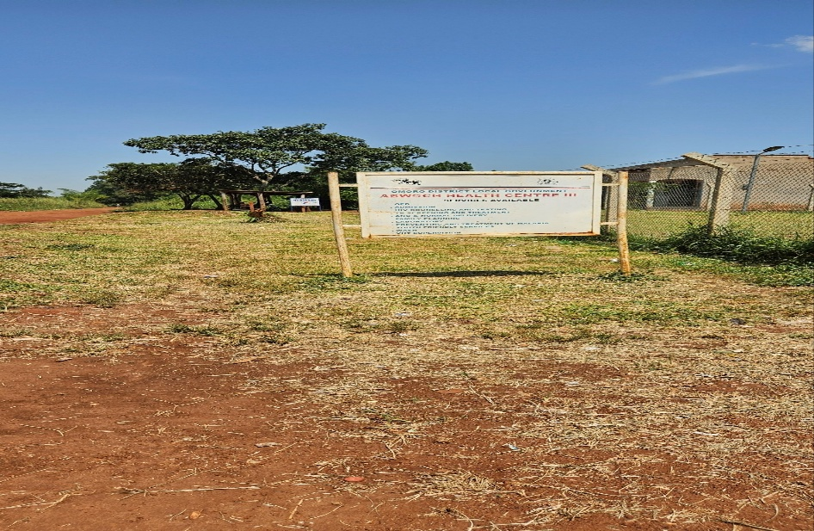
MATERNITY BLOCK (FRONT VIEW) | 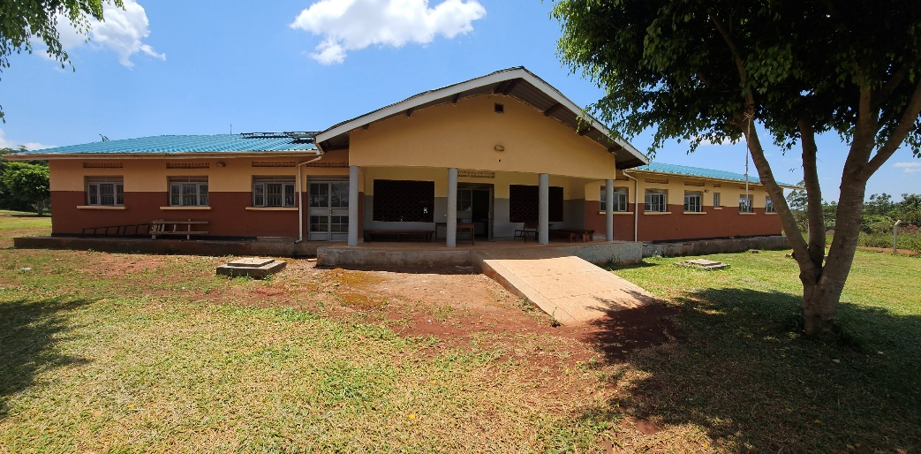
TYPICAL SET OF PATIENT LATRINES  (FOUR STANCE TOILET BLOCK ONE SIDE MALE AND OTHER FEMALE) | 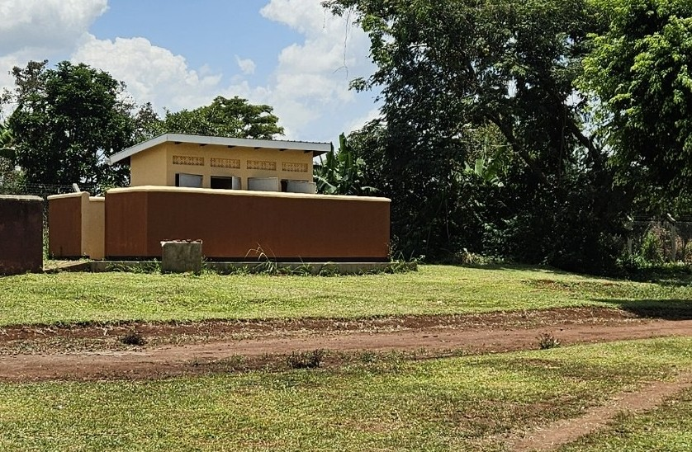
WATER TANKS FOR THE MATERNITY BLOCK | 